Identification of the Potential Market Segment of Traditional Medicine Products Based on the Level of Preference, Satisfaction and Risk Perception
Rizka Zulfikar
Prihatini Ade Mayvita
Purboyo
Hj. Farida Yulianti
Universitas Islam Kalimantan MAB, Banjarmasin, Indonesia
ABSTRACT: This study aims to describe the potential market segments of traditional medicine products demographically by measuring the level of preference, satisfaction, and perceptions of community risk. This can be used by traditional medicine product manufacturers to determine the target market. The research was conducted in Banjarmasin starting from October 2018 to March 2019 and the population consisted of the Banjarmasin community, with up to 150 respondents. The sampling method used was purposive sampling, while data was collected using a questionnaire and data editing was carried out. Furthermore, this study uses qualitative - quantitative descriptive analysis and average comparison test. The results of the study found that: (1) Preference level, satisfaction and risk perceptions of the Banjarmasin community in terms of traditional medicine products were fairly good because the respondents' evaluations were in the middle category; (2) the potential demographic segment is used as a target market for green products, namely, the female gender, ages between 21-30 years, occupation comprising Government employees and Students, income between Rp. 1 - Rp. 4.9 Million, and education level from elementary to undergraduate.

1. INTRODUCTION
Some of the green products currently being developed are the products in the traditional medicine sector (TM) which consists of herbal products, standardized traditional medicines, and phytopharmaca. This is one of the mainstay sectors driving the Indonesian economy. Data from the Indonesia BPOM (National Agency of Drug and Food Control) shows that there are at least 751 businesses that produce traditional medicines and 626 of them are middle, small and micro enterprises (MSMEs) (BPOM-RI, 2018). Based on data from health research in 2017, almost half (49.53%) of the Indonesian population are in the age group of 15 years and above, while the proportion that consumes herbal medicine daily is 4.36%, and the rest (45.17%) consume it occasionally (BPOM-RI, 2018).
In order to further develop products in the traditional medicine sector, this study was conducted to determine the potential market segments of green products by measuring the level of preference, satisfaction and public risk perceptions which can then be used by the product developers for marketing policies. Based on this background, the problem statement was developed as follows:
- What are preferences, satisfaction and risk perceptions levels of the Banjarmasin community on traditional medicine products demographically?
- What are the potential segments of traditional medicine consumers?

2. LITERATURE REVIEW
Marketing segmentation is an attempt to divide the market into groups that can be distinguished from each other in terms of needs, characteristics, or behavior which might require certain products and marketing strategies to reach them (Kotler and Armstrong, 2012).
Factors such as gender, age, income level and type of work influence the satisfaction of green products in order to increase their buying interest (Schiffman and Kanuk, 2008; Hamzan and Bayu, 2013).
- Gender factors: Women tend to be more positive towards green products than men (Lee, 2009; Zulfikar, 2017) and the purchase behavior of these products is a more relevant concept for women because they tend to have a greater concern for environmental issues (Lee, 2009, Zulfikar, 2018).
- Age factor: The buying behavior of the age group 18 to 24 uses the information contained in a product to make purchases, while there is a significant indication that information on a product greatly influences the purchase behavior of those between 25 to 44 years (Dumanovsky et al, 2010, Zulfikar, 2017).
- Occupation: Consumers who have certain types of work generally consume different items compared to those with other types of work (Kasali, 2007).
- Income Level Factors: Income levels significantly influence the satisfaction of green products and are the most dominant variable in influencing purchasing decisions (Samin et al, 2013; Hamzan, 2013; and Girard, 2010).
- Education Level Factors: Tsakiridou (2012) found that the level of education had a significant effect on the purchase of green products for consumers in Malaysia because better understanding and knowledge come with a good level of education, and these become the basis for consideration in purchasing green products. This is in line with the opinion expressed by Kim and Seock (2009) that knowledge has an important role in attitudes of consumer acceptance because those with knowledge of environmental issues and product benefits tend to prefer these products even though the price is relatively expensive.
However, there are also some findings that are contrary to such prior research, for instance, gender differences do not mediate knowledge variables in influencing consumer satisfaction and even though there is a tendency for knowledge, consumers prefer green products to others (Aryanti et al., 2014). Contributions of age, education, occupation, income, and family size variables are not significant to purchasing decisions and are likely influenced by other variables (Yahya, 2011).

3. RESEARCH METHODS
As a survey research, the population and sample comprises the Banjarmasin people and 150 respondents, respectively. This research uses data analysis techniques such as (1) descriptive qualitative-quantitative analysis, (2) descriptive analysis - variable categorization and (3) comparing Means test.

4. RESULTS AND DISCUSSION

4.1. Characteristics of Respondents
The characteristics of the respondents used in the study are presented in table 1 below:
Table 1. Characteristics of Respondents
Demographics Factor | Respondents |  | Demographics Factor  Freq | Respondents  Demographics Factor
 | Freq | % |  | Freq | %
Gender |  |  | Entrepreneur | 32 | 21
Male | 61 | 41 | Professional | 6 | 4
Female | 89 | 59 | Income
Age |  |  | < Rp 1 Million | 18 | 12
< 20 Years | 26 | 17 | Rp 1– Rp 2,49 Million | 27 | 18
21 – 30 Years | 29 | 19 | Rp 2,5– Rp 4,9 Million | 39 | 26
31 – 40 Years | 34 | 23 | Rp 5– Rp 9,9 Million | 34 | 23
41 - 50 Years | 36 | 24 | > Rp 10 Milion | 32 | 21
> 50 years | 25 | 17 | Education
Occupation |  |  | Elementary/Junior/High School | 36 | 24
Unemployed | 7 | 5 | Diploma (D1,D2, D3) | 4 | 3
Student | 26 | 17 | Under Graduate | 64 | 43
Gov. Employee | 34 | 23 | Graduate | 36 | 24
Private Employee | 45 | 30 | Post Graduate | 10 | 7
Source: Primary Data, Processed, 2019

3.2. Descriptive Analysis and Variable Categorization
The results of the categorization of variables based on average values ​​and standard deviations are presented in table 2 as follows:

Table 2. Categorization Variables
Variables | Mean | Standard Deviation | Respondent Assessment
 |  |  | High | Middle | Low
Preferences | 52.6 | 5.39 | 17% | 69% | 14%
Satisfaction | 0.79 | 4.58 | 52% | 43% | 5%
Risk Perception | 16.57 | 3.75 | 25% | 44% | 31%

Furthermore, the results in table 2 are explained as follows:
- 17% of the respondents gave an assessment of the preference variables in the high category, 69% in the middle category, and 14% were found in the low category. The data shows that the majority of respondents were in the middle category, therefore, it can be concluded that the level of the community’s preference for traditional medicine products was fairly good.
- 52% of the respondents gave an assessment of the satisfaction variable in the high category, 43% in the middle category, and 5% were in the low category. The data shows that most respondents assessed the satisfaction variable in the high category, thus, it can be concluded that the level of community satisfaction with traditional medicine products was very good.
- There were 25% of respondents that gave an assessment of the risk perception variables in the high category, 44% respondents in the middle category, and up to 31% were in the low category. The data shows that the majority of respondents assessed the risk perception of traditional medicine products as being in the middle category. This means that the people considered the risk of consuming traditional medicine remained fairly low.

3.3. Compare Means Analysis
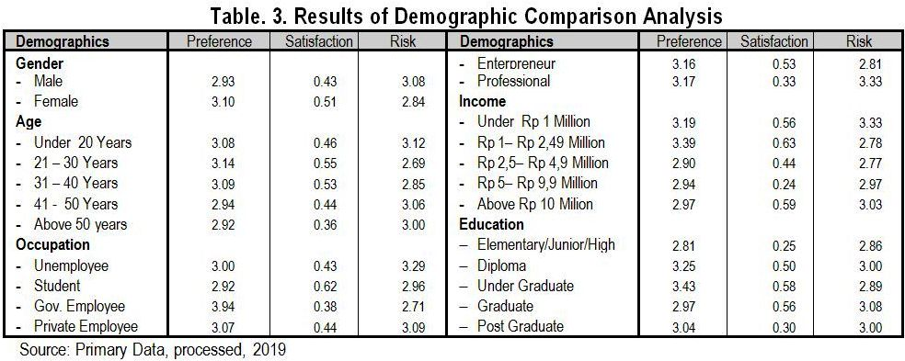
The average of all demographic segmentation groups was compared to the variables of preference, satisfaction and risk perception of the community towards traditional medicine products. Thus, the results are presented in Table 3.Based on the table, the variables are described as follows:
1 In terms of gender, women tend to have a better level of preference, satisfaction and risk perception of traditional medicine products compared to men.
2 In term of age, the group of 21-30 years tends to have a higher level of preference, satisfaction and perception of traditional medicine products than the other age groups.
3 In regard to occupation, respondents who are government employees have a better level of preference and risk perception than other occupational groups, while students tend to have greater levels of satisfaction.
4 Concerning income, the group of respondents with an income level of Rp. 1 million - Rp. 2,499 million have a higher level of preference and satisfaction. While in terms of risk perception, groups with an income level of Rp. 2.49 - Rp. 4.99 million have a greater level of risk perception for traditional medicine products. Thus, it can be posited that the potential consumers for these products are in the Rp. 1 million - Rp. 4.9 million income group.
5 Regarding education, respondents with an undergraduate education level tend to have higher preference and satisfaction levels than other groups while those with elementary/ junior/senior high school education have the highest satisfaction.
6. Based on the highest results of respondent evaluations on demographics, the groups which can be used as market potential for traditional medicine products are the female gender, age group of 21-30 years, the occupations of government employee and students, income between Rp. 1 million - Rp. 4.9 Million, and education level from elementary to undergraduate.

CONCLUSION
From the results of the data analysis and research findings, some conclusions are made:
1) The preference, satisfaction, and risk perception levels of the Banjarmasin community on green products in the traditional medicine sector are fairly good because the majority give an assessment in the middle category.
2) Potential groups that can be used as the target market for traditional medicine products are the female gender, the age group of 21-30, government employees and students, income between Rp. 1 Million - Rp. 4.9 Million, and the elementary to undergraduate education level.

REFERENCES
Aryanti, T. Utami, R.D. and Gunarsih. (2014). Pengaruh Pengetahuan, Kepedulian, dan Sikap pada Lingkungan terhadap Minat Pembelian Produk Hijau.Media Trend.9 ( 2) : 151-161.
Girard, T.(2010). The Role of Demographics on The Susceptibility to Social Influence: A Pretest Study. Journal of Marketing Development and Competitiveness. 5(1) : 9 - 22.
Hamzan, W. and Bayu, R. (2013). Hubungan Variabel Demografi dengan Respon Konsumen Terhadap Iklan Merk Top Coffe di Kota Denpasar. Jurnal Ekonomi, 2(9) : 1036-1052.
Kotler, P. And Armstrong, G. (2012). Principles of Marketing. Edisi keempat belas. Pearson-Prentice Hall.: New Jersey.
Kim, S. dan Seock, Y. K. (2009). Impacts Of Health And Environmental Consciousness On Young Female Consumers' Attitude Towards And Purchase Of Natural Beauty Products. International Journal Of Consumer Studies, 33(6) : 627-638.
Lee, K.H. (2009). Why and how to adopt green management into business organizations?: The case study of Korean SMEs in manufacturing industry. Management Decision. 47(7) : 1101-1121.
Samin, R. Rahman, M. S. and Javadian, J. (2013). Consumers Perceptual Differences in Buying Cosmetic Products : Malaysia Perspective. International Journal of Scientific Research, 16(11) : 345 - 355.
Schiffman, L.G. and Kanuk, L.L. (2008). Perilaku Konsumen.. Edisi Ketujuh. PT. Indeks. Jakarta.
Tsakiridou, E., Mattas, K. and Bazoche, P., (2012). Consumers response on the labels of fresh fruits and related implications on pesticide use. Food Economics, 9(1-2) : 129-134.
Yahya. (2011). Pengaruh Variabel Demografi Konsumen Terhadap Keputusan Pembelian Produk. Jurnal Ekonomi. 8(1) : 23-40.
Zulfikar, R., and Mayvita, P.A, (2017). Tingkat Kepercayaan dan Minat Beli Masyarakat Banjarmasin Terhadap Produk Hijau Berdasarkan Segmentasi Demografis. Proceeding of National Conference on Asbis. 2(1) : 410 – 426.
Zulfikar, R and Mayvita, PA. (2018). The Relationship of Perceived Value, Perceived Risk, and Level of Trust Towards Green Products of Fast Moving Consumer Goods Purchase Intention. JEMA: Jurnal Ilmiah Bidang Akuntansi dan Manajemen, Vol. 15, No. 2 : 85-97.

